**[연습문제]**

1. 메뉴 중 ( 1 )메뉴는 키패드의 MENU 버튼을 누르며 화면 하단에 나오고, ( 2 ) 메뉴는 위젯을 롱클릭하면 나온다.

2. "항목1"와 "항목2"로 구성된 메뉴 XML 파일을 코딩하라.

3. 위 2번의 XML 파일에 대응되는 onOptionsItemSelected()을 코딩하라.

4. 옵션메뉴를 선택하면 동물의 사진이 바뀌는 프로젝트를 작성하라. 단, 메뉴 XML 파일은 없이 작성하라.

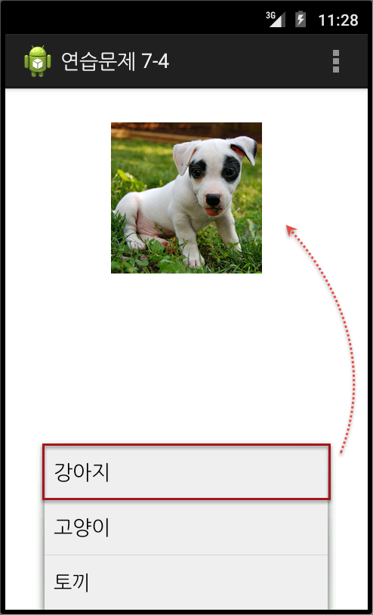

5. 버튼을 누르면, 이미지가 들어간 토스트가 임의의 위치에 나오는 프로젝트를 작성하라.

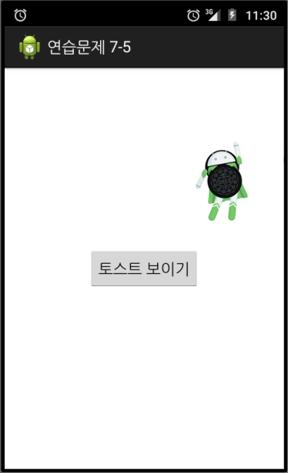

6. 초기화면에서 라디오버튼으로 3가지 동물이름을 선택할 수 있게 하고, <그림보기>를 클릭하면 대화상자로 그림이 나오도록 한다.

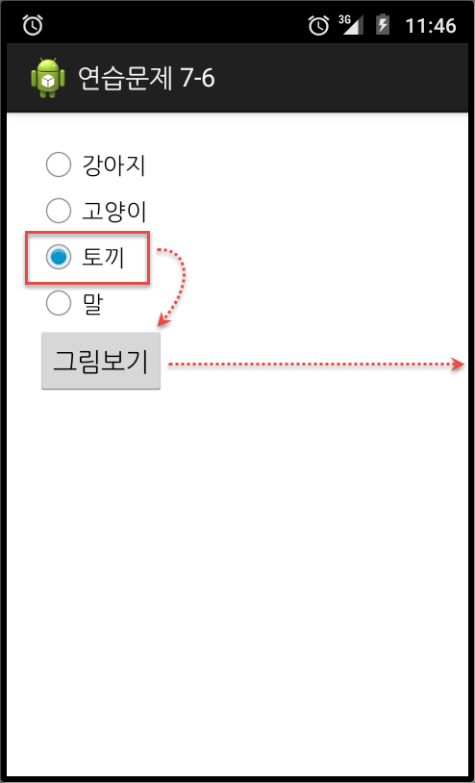 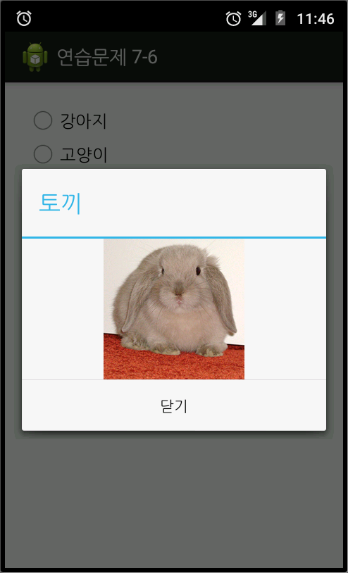

**[연습문제-답안]**

1. (1) 옵션 (2) 컨덱스트

2.

|  |
| --- |
| <menu xmlns:android="http://schemas.android.com/apk/res/android" >  　 <item  android:id="@+id/item1"  android:title="항목1">  </item>  <item  android:id="@+id/itemTri"  android:title="세모">  </item>  </menu> |

3.

|  |
| --- |
| public boolean onOptionsItemSelected(MenuItem item) {  switch (item.getItemId()) {  case R.id.item1:  //항목1 선택하면 실행할 코드…  return true;  case R.id.item2:  // 항목2 선택하면 실행할 코드…  return true;  }  return false;  } |

4.

****** activity_main.xml ******

<LinearLayout xmlns:android="http://schemas.android.com/apk/res/android"

android:layout_width="fill_parent"

android:layout_height="fill_parent"

android:gravity="center_horizontal"

android:orientation="vertical"

android:layout_margin="30dp">

<ImageView

android:id="@+id/imageView1"

android:layout_width="wrap_content"

android:layout_height="wrap_content"

android:src="@drawable/dog" />

</LinearLayout>

***** Java 코드 *****

package com.cookandroid.exercise07_4;

import android.app.Activity;

import android.os.Bundle;

import android.view.Menu;

import android.view.MenuItem;

import android.widget.ImageView;

public class MainActivity extends Activity {

ImageView imageView1;

/** Called when the activity is first created. */

@Override

public void onCreate(Bundle savedInstanceState) {

super.onCreate(savedInstanceState);

setContentView(R.layout.activity_main);

setTitle("연습문제 7-4");

imageView1 = (ImageView) findViewById(R.id.imageView1);

}

@Override

public boolean onCreateOptionsMenu(Menu menu) {

super.onCreateOptionsMenu(menu);

menu.add(0, 1, 0, "강아지");

menu.add(0, 2, 0, "고양이");

menu.add(0, 3, 0, "토끼");

return true;

}

@Override

public boolean onOptionsItemSelected(MenuItem item) {

switch (item.getItemId()) {

case 1:

imageView1.setImageResource(R.drawable.dog);

return true;

case 2:

imageView1.setImageResource(R.drawable.cat);

return true;

case 3:

imageView1.setImageResource(R.drawable.rabbit);

return true;

}

return false;

}

}

5.

**** toast.xml ****

<LinearLayout xmlns:android="http://schemas.android.com/apk/res/android"

android:layout_width="match_parent"

android:layout_height="match_parent"

android:orientation="vertical" >

<ImageView

android:id="@+id/imageView1"

android:layout_width="wrap_content"

android:layout_height="wrap_content"

android:src="@drawable/icecream" />

</LinearLayout>

**** activity_main.xml ****

<LinearLayout xmlns:android="http://schemas.android.com/apk/res/android"

android:layout_width="fill_parent"

android:layout_height="fill_parent"

android:orientation="vertical"

android:gravity="center" >

<Button

android:id="@+id/button1"

android:layout_width="wrap_content"

android:layout_height="wrap_content"

android:text="토스트 보이기" />

</LinearLayout>

**** Java 코드 ****

package com.cookandroid.exercise07_5;

import android.app.Activity;

import android.os.Bundle;

import android.view.Display;

import android.view.Gravity;

import android.view.View;

import android.view.WindowManager;

import android.widget.Button;

import android.widget.Toast;

public class MainActivity extends Activity {

Button btn;

View toastView;

/** Called when the activity is first created. */

@Override

public void onCreate(Bundle savedInstanceState) {

super.onCreate(savedInstanceState);

setContentView(R.layout.activity_main);

setTitle("연습문제 7-5");

btn = (Button) findViewById(R.id.button1);

btn.setOnClickListener(new View.OnClickListener() {

public void onClick(View v) {

Display display = ((WindowManager) getSystemService(WINDOW_SERVICE))

.getDefaultDisplay();

int xOffset = (int) (Math.random() * display.getWidth());

int yOffset = (int) (Math.random() * display.getHeight());

Toast toast = new Toast(getApplicationContext());

toastView = (View) View.inflate(getApplicationContext(),

R.layout.toast, null);

toast.setView(toastView);

toast.setGravity(Gravity.TOP | Gravity.LEFT, xOffset, yOffset);

toast.show();

}

});

}

}

6.

**** activity_main.xml ****

<LinearLayout xmlns:android="http://schemas.android.com/apk/res/android"

xmlns:tools="http://schemas.android.com/tools"

android:layout_width="fill_parent"

android:layout_height="fill_parent"

android:orientation="vertical"

android:padding="20dp" >

<RadioGroup

android:id="@+id/rGroup"

android:layout_width="wrap_content"

android:layout_height="wrap_content" >

<RadioButton

android:id="@+id/rdoDog"

android:layout_width="wrap_content"

android:layout_height="wrap_content"

android:text="강아지" />

<RadioButton

android:id="@+id/rdoCat"

android:layout_width="wrap_content"

android:layout_height="wrap_content"

android:text="고양이" />

<RadioButton

android:id="@+id/rdoRabbit"

android:layout_width="wrap_content"

android:layout_height="wrap_content"

android:text="토끼" />

<RadioButton

android:id="@+id/rdoHorse"

android:layout_width="wrap_content"

android:layout_height="wrap_content"

android:text="말" />

</RadioGroup>

<Button

android:id="@+id/btnImage"

android:layout_width="wrap_content"

android:layout_height="wrap_content"

android:text="그림보기" />

</LinearLayout>

**** dialog1.xml ****

<LinearLayout xmlns:android="http://schemas.android.com/apk/res/android"

android:layout_width="match_parent"

android:layout_height="match_parent"

android:gravity="center"

android:orientation="vertical" >

<ImageView

android:id="@+id/ivPet"

android:layout_width="wrap_content"

android:layout_height="wrap_content" />

</LinearLayout>

**** Java 코드 ****

package com.cookandroid.exercise07_6;

import android.app.Activity;

import android.app.AlertDialog;

import android.os.Bundle;

import android.view.View;

import android.widget.Button;

import android.widget.ImageView;

import android.widget.RadioButton;

import android.widget.RadioGroup;

public class MainActivity extends Activity {

/** Called when the activity is first created. */

RadioGroup rGroup;

RadioButton rdoDog, rdoCat, rdoRabbit, rdoHorse;

Button btnImage;

@Override

public void onCreate(Bundle savedInstanceState) {

super.onCreate(savedInstanceState);

setContentView(R.layout.activity_main);

setTitle("연습문제 7-6");

rGroup = (RadioGroup) findViewById(R.id.rGroup);

rdoDog = (RadioButton) findViewById(R.id.rdoDog);

rdoCat = (RadioButton) findViewById(R.id.rdoCat);

rdoRabbit = (RadioButton) findViewById(R.id.rdoRabbit);

rdoHorse = (RadioButton) findViewById(R.id.rdoHorse);

btnImage = (Button) findViewById(R.id.btnImage);

final Integer[] radioID = { R.id.rdoDog, R.id.rdoCat, R.id.rdoRabbit,

R.id.rdoHorse };

final Integer[] petID = { R.drawable.dog, R.drawable.cat,

R.drawable.rabbit, R.drawable.horse };

btnImage.setOnClickListener(new View.OnClickListener() {

public void onClick(View v) {

int pos = rGroup.getCheckedRadioButtonId();

View dialogView = (View) View.inflate(MainActivity.this,

R.layout.dialog1, null);

AlertDialog.Builder dlg = new AlertDialog.Builder(

MainActivity.this);

ImageView ivPet = (ImageView) dialogView

.findViewById(R.id.ivPet);

switch (rGroup.getCheckedRadioButtonId()) {

case R.id.rdoDog:

ivPet.setImageResource(petID[0]);

dlg.setTitle("강아지");

break;

case R.id.rdoCat:

ivPet.setImageResource(petID[1]);

dlg.setTitle("고양이");

break;

case R.id.rdoRabbit:

ivPet.setImageResource(petID[2]);

dlg.setTitle("토끼");

break;

case R.id.rdoHorse:

ivPet.setImageResource(petID[3]);

dlg.setTitle("말");

break;

}

dlg.setView(dialogView);

dlg.setNegativeButton("닫기", null);

dlg.show();

}

});

}

}